1. Which signals are triggered, when the following actions are performed.
2. user press ctrl+C

Answer: SIGINT signal (2)

1. kill() system call is invoked

Answer: SIGTERM signal (15)

1. CPU tried to execute an illegal instruction

Answer: SIGILL signal (4)

1. When the program access the unassigned memory

Answer: SIGSEGV signal (11)

 ---------------------------------------------------------------------------------------------------------------

1. List the gdb command for the following operations
2. To run the current executable file

Answer: >run or >run arg

1. To create breakpoints at

Answer: >break <line_number> or >break <function_name>

1. To resume execution once after breakpoint

Answer: >continue

1. To clear break point created for a function

Answer: >clear [line number] or >clear [FUNCTION_NAME]

1. Print the parameters of the function in the backtrace

Answer: >backtrace

>frame <frame_number>

>info args

----------------------------------------------------------------------------------------------------------------

1. Guess the output for the following program.

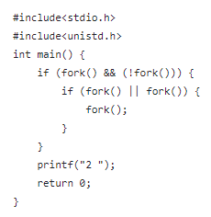 Answer: 2 2 2 2 2 2 2

4. Guess the output for the following program.

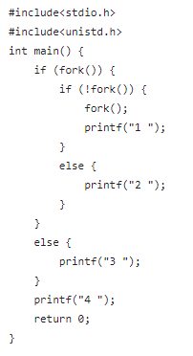

Answer: 2 4,

2 4 3 4,

3 4 2 4 1 4 1 4,

2 4 1 4 1 4 3 4 ,

2 4 3 4 1 4 1 4 ,

2 4 1 4 3 4 1 4 ,etc.

This program provides different outputs on execution because of it’s concurrent nature of process execution.Hence,we get a variety of outputs.

----------------------------------------------------------------------------------------------------------------

6. How to avoid Race conditions and deadlocks?

Answer:

**To avoid race conditions**

1. Use Synchronization Mechanisms like locks,mutexes and semaphores.
2. Protect critical sections of code using locks and mutexes.

**To avoid deadlocks**

1. Avoid circular dependencies
2. Use time out mechanisms
3. Implement deadlock prevention mechanisms like banker’s algorithm.

----------------------------------------------------------------------------------------------------------------

7. What is the difference between exec and fork ?

Answer:

EXEC()

* The exec() command is used to replace the current process image with a new process.when exec() is called,the new program starts executing from its main() function or entry point.

FORK()

* The fork() is used to create a new process by duplicating the calling process.The new process is referred to as the child process, and the original process is referred to as the parent process.

8. What is the difference between process and threads.

Answer:

**Process**

* A process is a program in execution. It has its own memory space, which includes data and resources.
* Processes are isolated from each other and they cannot directly access each others memory space.
* Inter-process communication mechanisms such as pipes and shared memory are used for communication between processes.
* Processes are heavyweight in terms of resource consumption.

**Thread**

* A thread is a smallest unit of execution within a process. Multiple threads can exist within a single process and they can share same memory space.
* Threads within the same process can communicate directly with each other through shared memory.
* Threads share same resources of a process which can lead to synchronization problems.
* Threads are more efficient in terms of resource consumption as they share resources.